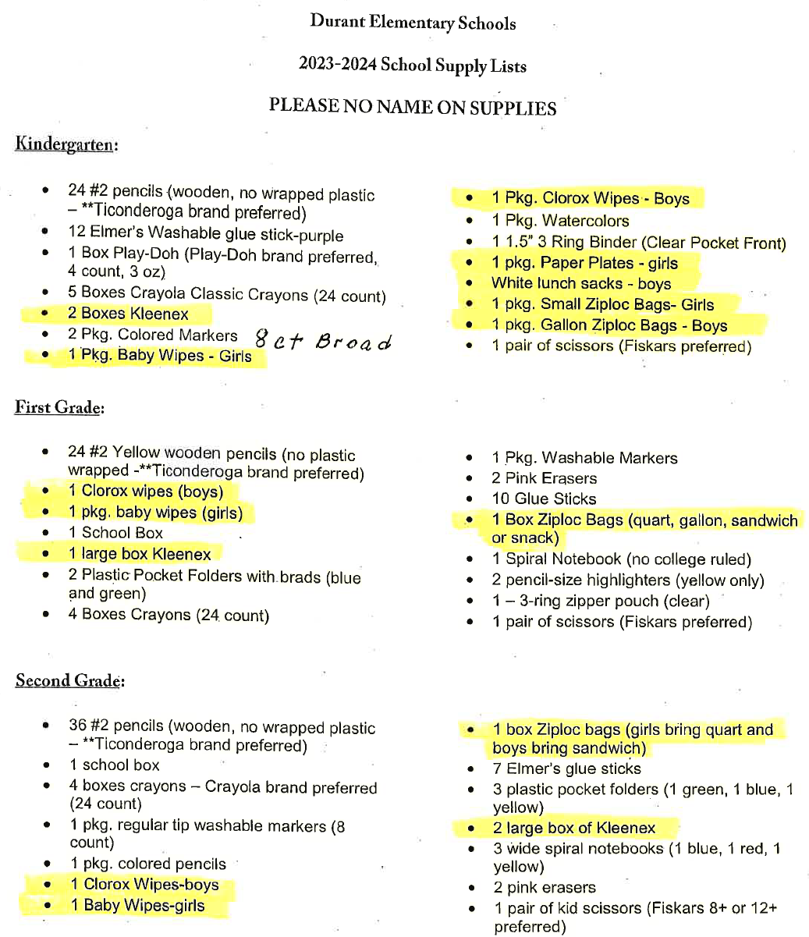
DISD Indian Education does not supply the highlighted items.

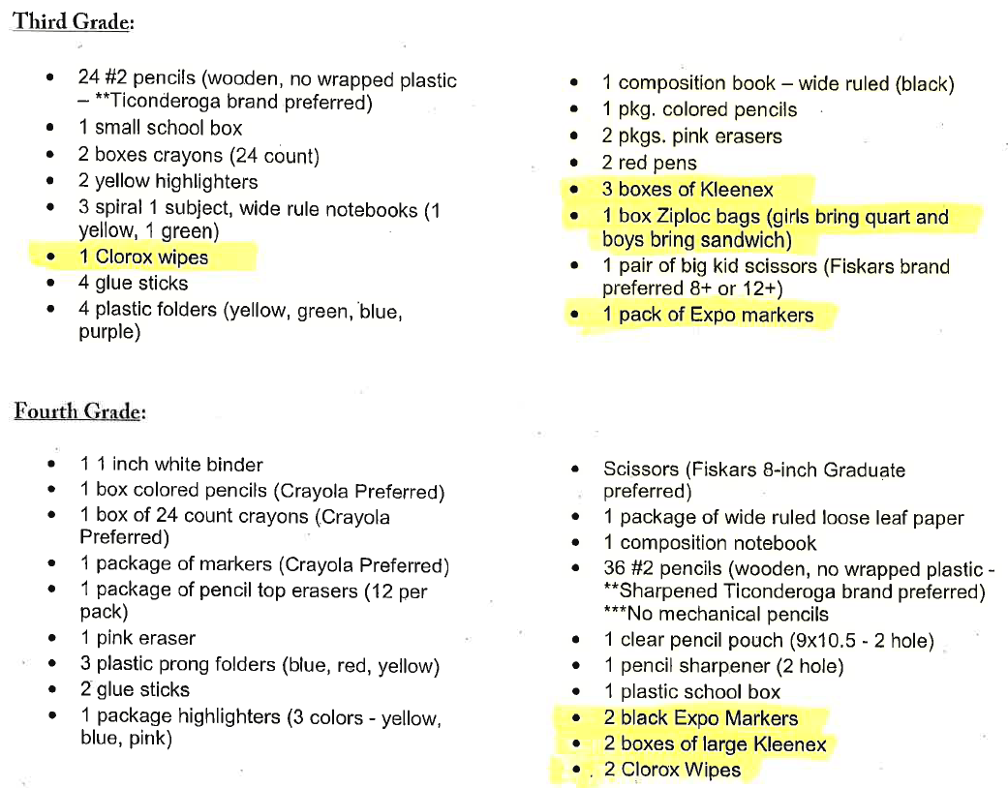

DISD Indian Education does not supply the highlighted items.

