Durant Middle School
Grades 7th and 8th
2023-2024 School Supply Lists
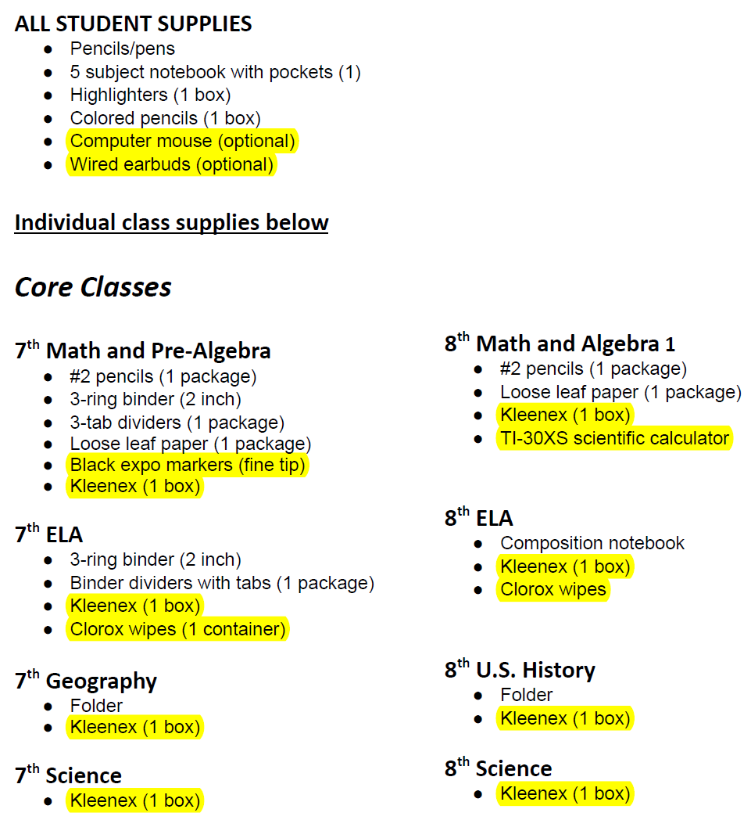
DISD Indian Education does not supply the highlighted items.

